Name: Khadijah Zahoor Reg. No.: F2023-956 Section No: C
Explore Private address spaces in IPv4 for each address class [CLO1]
Prepare a 2-page handout on:
Why were private IP address ranges introduced in IPv4 networks? [3]
How is security managed? [2]
Role of routers here? [2]
Examples [2]
Pros & Cons [2]
Check your home WiFi network. Find out your device IP address, is it private or public, find the default router (gateway) IP? [3]
Clearly include sources/references in your submission [1]

Solution:
1. Why were private IP address ranges introduced in IPv4 networks?
Private IP address ranges were introduced to solve the problem of IPv4 address exhaustion. IPv4 uses a 32-bit addressing system that provides approximately 4.3 billion unique IP addresses. As the number of internet users, computers, smartphones, and IoT devices increased rapidly, the available public IP addresses started running out.
To address this issue, the Internet Engineering Task Force (IETF) defined private IP address ranges in RFC 1918. These addresses are used within local networks such as homes, schools, offices, and organizations.
Devices using private IP addresses cannot directly communicate with the public internet. Instead, they communicate through a router that performs Network Address Translation (NAT). NAT converts private IP addresses into a public IP address when accessing the internet. This allows multiple devices inside a local network to share a single public IP address, helping conserve the limited IPv4 address space and making network management more efficient.

2. How is security managed?
Security in private IP networks is mainly managed through network isolation and address translation.Private IP addresses are not accessible directly from the public internet. This prevents external users from directly accessing internal devices within a local network.
Routers use Network Address Translation (NAT) to hide internal IP addresses when devices communicate with the internet. Additionally, routers often include firewalls that monitor incoming and outgoing network traffic. These security mechanisms help prevent unauthorized access and protect the internal network from potential cyber threats.

3. Role of routers here?
Routers play a very important role in private IP networks.
- They act as the default gateway, connecting the local network to the internet.
- Perform Network Address Translation (NAT) that converts private IP addresses into a public IP address so that devices inside the local network can access external networks.
- Manage network communication and often provide DHCP (Dynamic Host Configuration Protocol) services, which automatically assign IP addresses to devices connected to the network.
Therefore, routers ensure proper communication between devices in a local network and external networks such as the internet.

4. Examples

According to RFC 1918, the following IP address ranges are reserved for private networks:

Class | Private IP Range
Class A | 10.0.0.0 – 10.255.255.255
Class B | 172.16.0.0 – 172.31.255.255
Class C | 192.168.0.0 – 192.168.255.255

5. Pros & Cons

Advantages
- Helps conserve the limited IPv4 address space
- Provides basic network security by hiding internal IP addresses
- Allows multiple devices to share one public IP address through NAT
- Efficient for local network communication

Disadvantages
- Requires NAT configuration for internet access
- Some applications such as peer-to-peer networking may face connectivity issues
- Troubleshooting network problems can become more complex

6. Check your home WiFi network. Find your device IP address, determine whether it is private or public, and find the default router (gateway) IP.
After running the ipconfig command in Command Prompt, the following information was obtained from the Wi-Fi adapter.
Device IP Address:
192.168.0.124
Subnet Mask:
255.255.255.0
Default Gateway (Router IP):
192.168.0.1
The IP address 192.168.0.124 falls within the range 192.168.0.0 – 192.168.255.255, which belongs to the Class C private IP address range defined in RFC 1918.
Therefore, my device is using a Private IPv4 address.
The default gateway 192.168.0.1 represents the router that connects the local network to the internet and performs NAT so that devices in the private network can communicate with external networks.

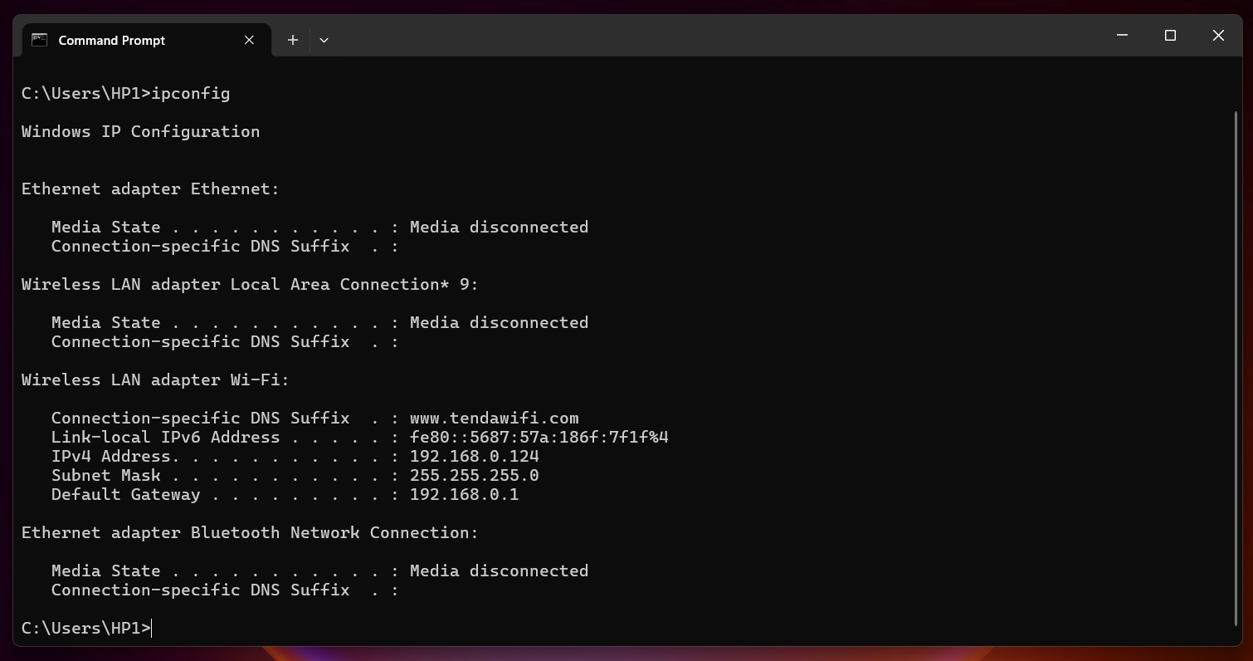

References:
https://datatracker.ietf.org/doc/html/rfc1918
https://www.geeksforgeeks.org/computer-networks/private-ip-addresses-in-networking/
https://www.cisco.com/c/en/us/support/docs/ip/network-address-translation-nat/4606-8.html https://www.techtarget.com/searchnetworking/tip/Introduction-to-IP-addressing-and-subnetting

